ABSTRACT
Big data is an analytical engine that can process large volumes of data which is in tera or peta byte size, it is often confused to storing of large amount of data but it’s not. Analysis of data sets can find new correlations to spot business trends, prevent diseases, predict decisions and so on. We are implementing a project which extracts the information from Tweets in Twitter and perform Sentiment Analysis on Twitter data using bigdata. We will be getting to know about the Positive and Negative Tweets on Political Leader, who are going to stand for election and determine who maybe the next Leader. To begin with, we will be collecting real-time tweets from Twitter using Flume. Data transformation in Hadoop is completed using a process called MapReduce in Java or can be system generated by tools such as Hive (a SQL like language for Hadoop that many data analysts would be immediately comfortable with) or PIG (a procedural scripting language for Hadoop). Run queries on top of data and provide information. By doing all this we are going to provide the information about who will be the next leader.

Keywords: Sentimental analysis.

- Introduction:
Social networking site uses opinion mining has been recently introduced to extract useful information from text and multimedia data. A new real-time method is required to extract the ideas and thoughts from this huge data. Such information can prove useful in many fields, such as economics, politics, media, culture. However, there are a lot of data on social networking sites, technologies that can efficiently process large amounts of unstructured data to obtain the necessary information are very important as fundamental technologies in social media data processing.
Social media is social interaction among people, in which they create, share, or exchange information, ideas, and pictures, videos, texts in virtual communities and networks. Social media contains many forms of multimedia information. Twitter contains various forms of information, such as video links, image links, and text data. In this, we focus on text data and we study methods for extraction of sentiment information from big-data text.
Since the data format is relatively easy and free, most social networking site data are unstructured. Unstructured data may be defined as data that has not been standardized, because its structure and shape are so complex, unlike video image data and document data. In order to extract meaningful information from large amounts of unstructured data on a social networking site, a structuring process is needed for the unstructured data. Up to now, various technologies for processing unstructured data have been studied, focusing on morphological analysis.
Various open sources associated with the processing of big data have been provided. The Hadoop ecosystem is a famous big data processing system that is most commonly used. Hadoop Distributed File System (HDFS) and MapReduce functions based on Hadoop are proposed, which collect and store a variety of data generated by social networks and analyze the sentiments of users on networks that have a lot of unstructured data.

  - Motivation
The work which was used in MuSigma was used to know which topic were discussed on twitter more and in which way. They conducted Sentimental analysis of data from Twitter to know about the trending technology discussed . The result was shown in the following way.
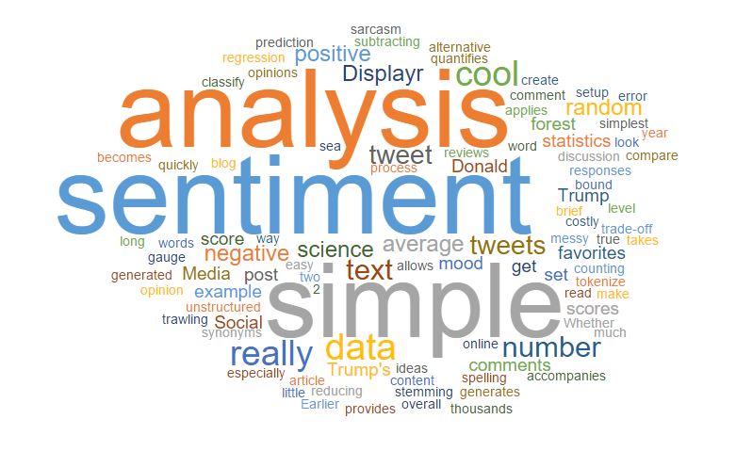
This work motivated us to work on this type of project which was utilized by us in predicting the next leader from the sentiments of twitter data.

1.2 Problem statement:
In this project, we extract the data from Twitter and perform Sentiment Analysis. Using this we will be predicting the next leader .

1.3 Objective:
Our aim is to find out the next coming up leader who will be leading us into bright futures. We are doing this by collecting twitter tweets on famous personalities who will be standing for this authority.

To Study:
Hadoop
Hadoop is an open-source software framework for storing data and running applications on clusters of commodity hardware. It provides massive storage for any kind of data, enormous processing power and the ability to handle virtually limitless concurrent tasks or jobs

Why is Hadoop important?
- Ability to store and process huge amounts of any kind of data, quickly. With increasing volumes and varieties of data, especially from social media and the Internet of Things (IoT), that's a key consideration.
- Computing power. The more computing nodes you use, the more processing power you have.
- Data Distribution. If a node goes down, jobs are automatically redirected to other nodes to make sure the distributed computing does not fail. Multiple copies of all data are stored automatically.
- Flexibility. Unlike relational databases, you don’t have to preprocess data before storing it. You can store as much data as you want and decide how to use it later. That includes unstructured data like text, images and videos.
- Low cost. The open-source framework is free and uses commodity hardware to store large quantities of data.
- Scalability. You can easily grow your system to handle more data simply by adding nodes. Little administration is required
To impliment:
- Sentimental Analysis
Sentiment analysis is the process of using text analytics to mine various sources of data for opinions. Often, sentiment analysis is done on the data that is collected from the Internet and from various social media platforms. Politicians and governments often use sentiment analysis to understand how the people feel about themselves and their policies.

Data is captured from different sources, such as mobile devices and web browsers, and it is stored in various data formats. Because the social media content is unstructured RDBMS, Relational Database Management System, we need tools that can process and analyze this data. However, big data technology is made to handle the different sources and different formats of the structured and unstructured data.

Every day massive amount of data is generated by social media users which can be used to analyze their opinion about any event, movie, product or politics. Conventional tools like Apache Storm analyze stream in micro-batch whereas novel tools like Apache Spark process data in real time making analyzing and processing of real time data possible.

Literature Survey

Survey 1: In this survey it has been stated that,

System Analysis & Design

Requirement Analysis
"Naive Bayes Classification" is termed such because it makes the assumption that each word is statistically independent from each other word. Sentiment analysis feels quite a bit like classification: given a document, would you label it "positive" or "negative"? The main difference between classification and sentiment analysis is the idea that classification is objective but sentiment is subjective. But let's make another "naive" assumption and pretend that we don't care about that. Let's try applying Bayes to sentiment and see what happens.
Our Bayes classifier can easily be extended to use tokenizing our document two words at a time instead of one! Rather than treating the words "This" "movie" "was" "not" "great" separately -- and risk getting confused by the negation -- all we have to do is record them as pairs: "This movie" "movie was" "was not" "not great".
Now our classifer knows the difference between "was great" and "not great"! In a text classification problem, we will use the words (or terms/tokens) of the document in order to classify it on the appropriate class. By using the “maximum a posteriori (MAP)” decision rule, we come up with the following classifier:

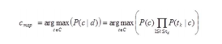
Where tk are the tokens (terms/words) of the document, C is the set of classes that is used in the classification, the conditional probability of class c given document d, the prior probability of class c and the conditional probability of token tk given class c.
This means that in order to find in which class we should classify a new document, we must estimate the product of the probability of each word of the document given a particular class (likelihood), multiplied by the probability of the particular class (prior). After calculating the above for all the classes of set C, we select the one with the highest probability.

Specifications
Software requirements:
· VMware Workstation 12 Player
· Ubuntu version-17.04 for hadoop version-2.0
· Python version-3.0.4
· Tweepy
· Pandas
· Numpy
· Textblob
· Matplotlib

Hardware requirements:
Some of the essential hardware requirements for installing Hadoop are:
· Intel Core 2 Duo/Quad/hex/Octa or higher end 64 bit processor PC or Laptop (Minimum operating frequency of 2.5GHz)
· Hard Disk capacity of 1- 4TB.
· 16-512 GB RAM
· 10 Gigabit Ethernet or Bonded Gigabit Ethernet

UML DIAGRAMS

Use case diagram
Use Cases. A use case is a written description of how users will perform tasks on your website. It outlines, from a user's point of view, a system's behavior as it responds to a request. Each use case is represented as a sequence of simple steps, beginning with a user's goal and ending when that goal is fulfilled.
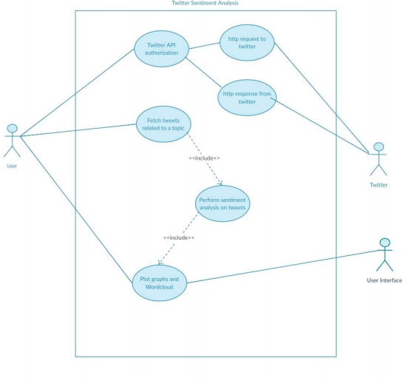
Figure 3.1 Use Case Diagram

Our project use diagram consists of user,twitter admin,user interface .User can access the twitter API upon authorization, he can fetch tweets and performs sentimental analysis and the results are shown in the form of graphs,pie charts etc.Twitter authorization requires http request to twitter and http response is sent to particular user after authorization from Twitter. The output is shown in such a way which is easily understandable i.e user-interface.
Sequence diagram
A sequence diagram simply depicts interaction between objects in a sequential order i.e. the order in which these interactions take place. We can also use the terms event diagrams or event scenarios to refer to a sequence diagram. Sequence diagrams describe how and in what order the objects in a system function.
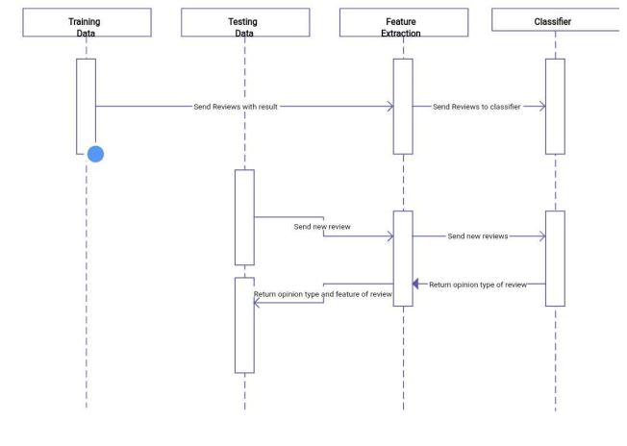
Figure 3.2 Sequence Diagram

This sequence diagram shows the sequence in which first the reviews are taken from the testing data and sent to the next scenario which is feature extraction .After the feature is extracted , these are sent to the classifier for getting sentiment.

Activity diagram
Activity diagram is another important diagram in UML to describe the dynamic aspects of the system. Activity diagram is basically a flowchart to represent the flow from one activity to another activity. The activity can be described as an operation of the system. The control flow is drawn from one operation to another.
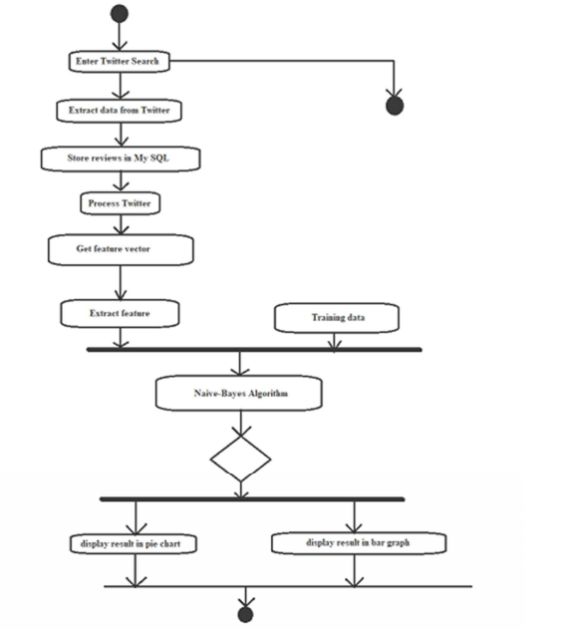

Figure 3.3 Activity Diagram
The activity diagram of our project represents a flow in which the process is carried out.First data is extracted from twitter about the political leaders and then each review is stored in database and from these reviews ,features are extracted .These are given to the Naive Bayes classifier for classification and display the results in either bar graph or pie chart.

System flow diagram
A system flow diagram is a way to show relationships between a business and its components, such as customers (according to IT Toolbox.)System flow diagrams, also known as process flow diagrams or data flow diagrams, are cousins to common flowcharts.
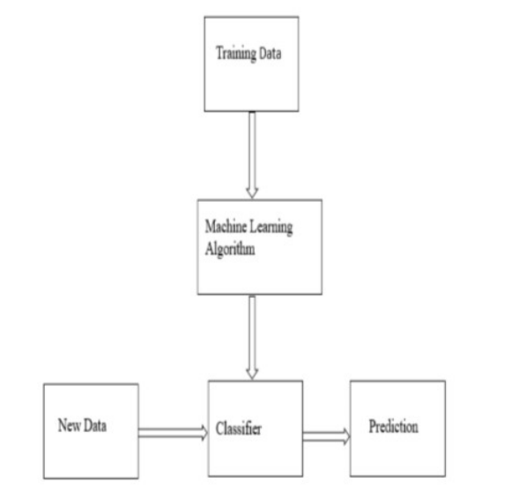

The system diagram of our project shows first the data related to the given keywords (political leaders in our project) is retrieved from twitter and this data is processed to get the feature.The features extracted are given to the Naive Bayes classifier for classification. After classification the scores of each political party are aggregated and the final result is shown in pie chart.

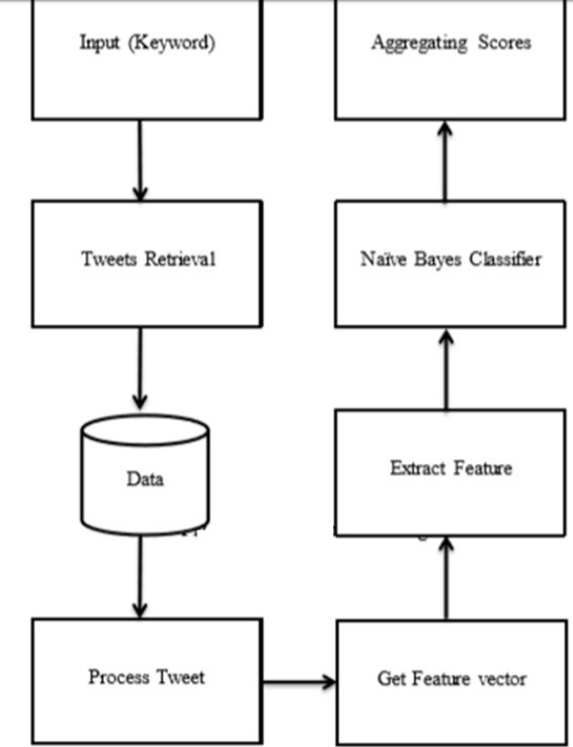

Figure 3.4 System Flow Diagram

Data flow diagram
A data flow diagram is a graphical representation of the "flow" of data through an information system, modelling its process aspects. A DFD is often used as a preliminary step to create an overview of the system without going into great detail, which can later be elaborated.
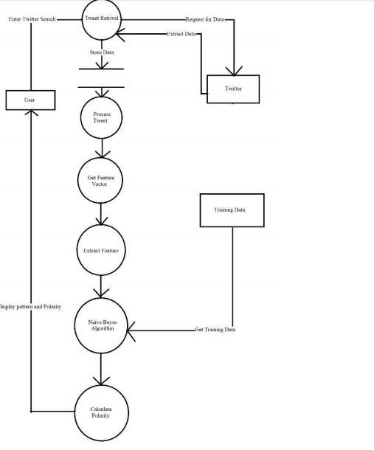
Figure 3.5 Data Flow Diagram
The data flow diagram of our project is the preliminary step which gives an overview of Tweet retrieval and Processing data,feature extraction and then passing them to the Naive Bayes classifier and calculating the polarity of each sentiment.
Methodology
System architecture
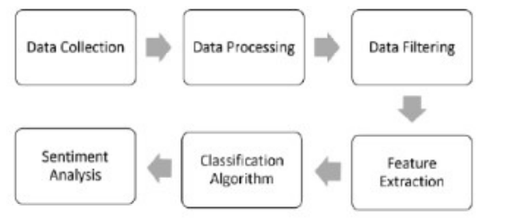
Social networking site uses opinion mining has been recently introduced to extract useful information from text and multimedia data. A new real-time method is required to extract the ideas and thoughts from this huge data. Such information can prove useful in many fields, such as economics, politics, media, culture. However, there are a lot of data on social networking sites, technologies that can efficiently process large amounts of unstructured data to obtain the necessary information are very important as fundamental technologies in social media data processing.
Social media is social interaction among people, in which they create, share, or exchange information, ideas, and pictures, videos, texts in virtual communities and networks. Social media contains many forms of multimedia information. Twitter contains various forms of information, such as video links, image links, and text data. In this, we focus on text data and we study methods for extraction of sentiment information from big-data text.
Since the data format is relatively easy and free, most social networking site data are unstructured. Unstructured data may be defined as data that has not been standardized, because its structure and shape are so complex, unlike video image data and document data. In order to extract meaningful information from large amounts of unstructured data on a social networking site, a structuring process is needed for the unstructured data. Up to now, various technologies for processing unstructured data have been studied, focusing on morphological analysis.
Various open sources associated with the processing of big data have been provided. The Hadoop ecosystem is a famous big data processing system that is most commonly used. Hadoop Distributed File System (HDFS) and MapReduce functions based on Hadoop are proposed, which collect and store a variety of data generated by social networks and analyze the sentiments of users on networks that have a lot of unstructured data.

- Steps to do Sentiment Analysis:
Data Collection:
We have to get the following API keys for data collection
consumer_key<-„xxxxxxxx’
consumer_secret<-'xxxxxxxxxxx’
access_token<-'xxxxxxxxxxxx’
access_secret<-„xxxxxxxxxxx’
This is done by creating a developer account in twitter

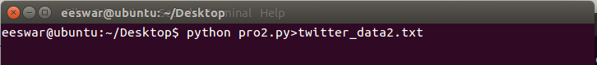
This figure represents the command for storing the collected data into a text file directly

Data Processing:
Data processing involves Tokenization which is the process of splitting the tweets into individual words called tokens. Tokens can be split using whitespace or punctuation characters. It can be unigram or bigram depending on the classification model used. The bag-of-words model is one of the most extensively used model for classification. It is based on the fact of assuming text to be classified as a bag or collection of individual words with no link or interdependence. The simplest way to incorporate this model in our project is by using unigrams as features. It is just a collection of individual words in the text to be classified, so, we split each tweet using whitespace.

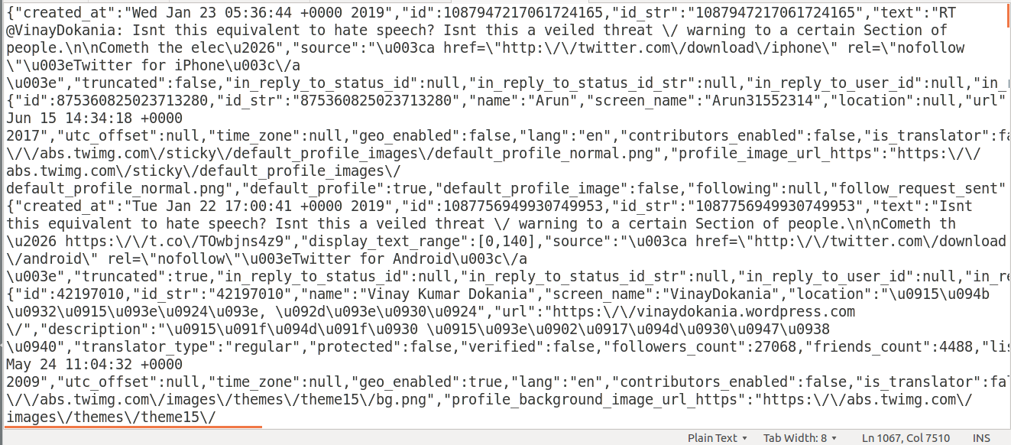
Figure 3 : This figure represents the screenshot of data collection in a text file

Data Filtering:
A tweet acquired after data processing still has a portion of raw information in it which we may or may not find useful for our application. Thus, these tweets are further filtered by removing stop words, numbers and punctuations.
We will be gathering data from multiple sources in multiple formats (structured, semi-structured, or unstructured), you need to consider setting up a Hadoop cluster and a Hadoop Distributed File System (HDFS) to store your data. An HDFS provides a flexible way of managing big data:
-We move some of your analyzed data into an existing relational database management system(RDBMS).
-We store the data in HDFS for future analysis, such as comparing old data with new data.
-We discard the data if you just need the analysis of the data at the point of impact.
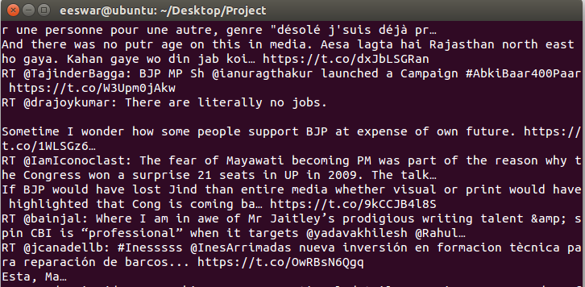
Figure 4 : This figure represents the filtering of tweets from the collected data

Data Extraction (Retrieving data from a Twitter feed):
Twitter, a popular blogging site, has a set of APIs that allows us to retrieve and manipulate tweets. First, however, we need to implement Twitter's OAuth framework. In simple terms, with this framework, an application can log in to Twitter on your behalf without you needing to log in on the Twitter website. Review the setup process on Twitter's developer site that explains how to designate the application that does this. In this process, you are assigned a key and a secret token that your application uses to authenticate on your behalf. After your application is authenticated, you can then use the Twitter APIs to fetch tweets.
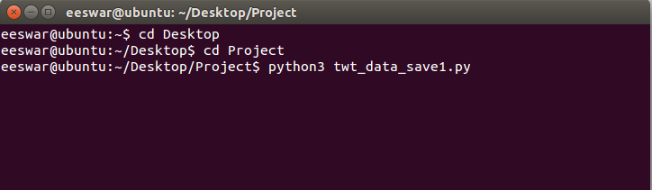

Figure 5: This figure represents the commands:
(i) for changing the directory (“cd”)
(ii) for running the python file for classifying the processed data

Sentiment Analysis:
Performing sentiment analysis on data:
Now that we combined the data, we can complete the sentiment analysis on a single data source, which allows for uniformity, consistency, and accuracy of our analyses. You can use Pig or Hive to do these analyses. Pig and Hive are SQL-like syntax languages that run on the Hadoop platform.
To complete sentiment analyses, we need to have a dictionary of words or word list. The dictionary includes a set of standard words that depicts positive and negative words within a context. It identifies sarcasm words, innuendos, slang terms, new vocabulary, characters, and smileys that are often used in social media.
To handle a variety of unstructured social networking site (SNS) data efficiently, a big data processing system is proposed[5]. The proposed system is comprised of a parallel HDFS and MapReduce. HDFS, which is the Hadoop ecosystem, is used to collect and store data from a large amount of SNS data. MapReduce is used to effectively analyze large amounts of unstructured data as to the sentiment of the user.
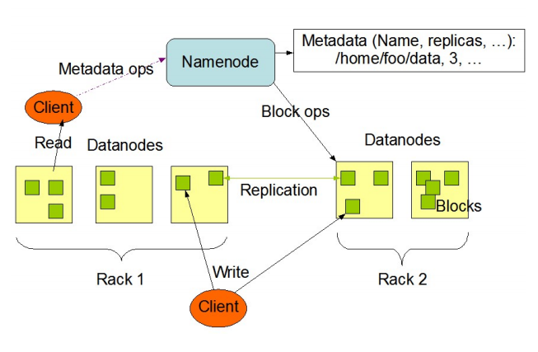
Figure 4.2 HDFS Architecture
The NameNode and DataNode are pieces of software designed to run on commodity machines. These machines typically run a GNU/Linux operating system (OS). HDFS is built using the Java language; any machine that supports Java can run the NameNode or the DataNode software. Usage of the highly portable Java language means that HDFS can be deployed on a wide range of machines. A typical deployment has a dedicated machine that runs only the NameNode software. Each of the other machines in the cluster runs one instance of the DataNode software. The architecture does not preclude running multiple DataNodes on the same machine but in a real deployment that is rarely the case.
The existence of a single NameNode in a cluster greatly simplifies the architecture of the system. The NameNode is the arbitrator and repository for all HDFS metadata. The system is designed in such a way that user data never flows through the NameNode. 29 HDFS is a file processing system that has a distributed processing structure. It is configured in parallel, as shown in the above Figure and each chunk node for storing data is set to 64 MB. It duplicates the name server using NFS for disaster recovery.

Functionality:
MapReduce:
MapReduce is a software framework developed by Google to support distributed computing, and it allows parallel programming using the function concept called Map. In this paper, it is classified into four special Map functions. They perform polarity preprocessing analysis, syntactic word analysis, morpheme analysis, and prohibitive word analysis, stage by stage. Figure below shows the process of sentiment analysis using four sentiment analysis functions. Sentiment analysis is started from the loading of sentiment analysis dictionaries[6]. Then, the data are input and loaded to the parallel HDFS. Later, the stepwise sentiment analysis is processed by four sentiment analysis functions. Sentences that do not determine the sensitivity in the previous step move on to the next step. The results of the final sentiment analysis are stored in the database.
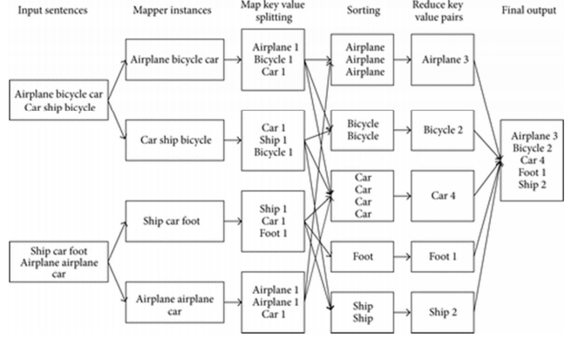
Figure 4.3 Example for MapReduce

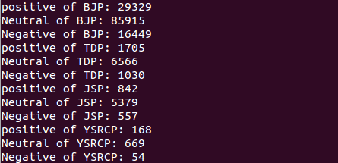
Figure 6 : This figure represents the sentiment of the analysis

Errors:
- ”The virtual machine appears to be in use” error.
- “pip install unroll:” “python setup.py egg_info” failed with error code 1.
- Textblob error.
- Matplotlib error
Error recovery:
For the virtual machine error, the solution is
- close VMware Workstation
- delete any .lck or .lock files and/or folders you see, in the directory of the problematic VM
- run VMWare Workstation
- start the VM

2. “pip install unroll” error resolved using,

pip install --upgrade setuptools
If it's already up to date, check that the module ez_setup is not missing. If it is, then
pip install ez_setup
Then try again
pip install unroll
If it's still not working, maybe pip didn't install/upgrade setup_tools properly so you might want to try
easy_install -U setuptools

3.The textblob and matplotlib errors are resolved after installing the python 2.7 and 3 versions.

Coding part:

